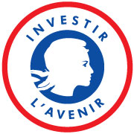
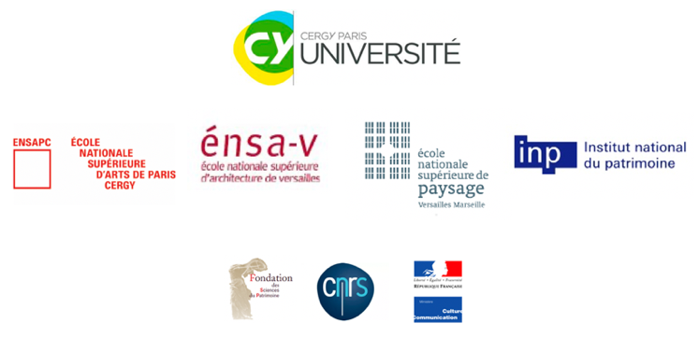
Call for proposal 2020
Request for enrolment in practice-led doctoral studies

Opening of the call : 23th March 2020 midday
Deadline for submission of proposals : 30th April 2020 midday

Important
12 pages maximum, excluding annexes.
The text in this file is to be completed in Calibri font, size 11, line spacing 1,5.

Please send proposals to the following platform:
https://aac-doctoratparprojet.u-cergy.fr/EsupDematEC/login
Candidates are invited to refer to the
Call rules for online submission procedures.

The complete file will contain:
- The application file presenting the thesis project, signed by the project leader and, where applicable, the thesis director and/or the project referent or the director of the host laboratory.
- A portfolio explaining the professional practice. It can contain photos, drawings, etc. For the mention Practice and Theory of literary writing, they may be relevant excerpts from the candidate's works. Websites are accepted, url links must be communicated in the portfolio.
The portfolio is limited to 5 (five) pages.
For the Arts category, the size of the document is not limited.
A document "Annex" containing the applicant's CV of maximum 5 (five) pages and any supporting documents (CV of co-supervisors, etc.).

Project initiator
Name:
Thesis project title:
Acronym (optional, if applicable):
Thesis supervisor (if identifed): | Teacher-researcher or researcher authorized to direct research at the Doctoral School of Law and Humanities at the University of Cergy Pontoise  (name/surname/telephone number/e mail address):  Laboratory or institution:  Co-Professional supervisor  (name/surname/telephone number/e mail address):  Laboratory or institution:
Other supervisors, if applicable | (name/surname/telephone number/e mail address):
Mention (only 1 choice possible) | ☐ Arts ☐ Landscape ☐ Architecture ☐ Heritage studies  ☐ Heritage conservation and restoration ☐ Creative writing
Research funding (complete the appropriate category) | Request for EUR funding (doctoral contract) | Other funding (doctoral contract, Cifre thesis, etc.)  ☐ requested ☐ obtained | Auto-financement, employed activity:  ☐ Yes ☐ No
 | ☐ Yes  ☐ No | Type of contract and duration :  Funder or employer :  Amount : | For employees, thesis request spread over 6 years  ☐ Yes ☐ No  Employer :

- Summary of the thesis project (20 lines maximum)
This summary may be used by the EUR for its communication.

- Objectives and description of the thesis subject (3 pages maximum)
For the description of the project, the candidate will pay particular attention to describing the problem envisaged or the questions likely to raise it, the scientific objectives and the strategy for achieving them.

- Registration of the subject in the context of a doctorate by the project (1/2 page maximum)
The candidate will endeavour to highlight the link between research theory and practice through the project.

- Importance of the doctorate for the project in the candidate’s career development (1/2 page maximum)
The candidate will present the Impact expected on the doctorate via the project on the development of his/her career.

- Supervision
To be completed only if the candidate has identified at least one supervisor.

- Teacher-researcher or HDR researcher from the ED DSH (2 pages maximum):
CV of the thesis director, if identified.

- Professionnel supervisor (2 pages maximum) :
CV of the professional supervising the thesis and presentation of the host institution, if relevant.

- Other supervisor (1 page maximum, if applicable) :
(Supervisor’s Curriculum)

- Possible professional partners and possible ways of promoting them (1/2 page maximum)
For example, institutions, communities, associations, companies, etc.
These developments will highlight the potential extensions and benefits.

- Bibliography
The bibliography elements will allow to identify the thesis project and will be limited to 15 bibliographical references maximum.

- Commitment of the project leader and partners

Each project partner is asked to confirm their commitment to participate in the work described (boxes can be added to the table):
- by signature on the file
or
- by commitment letter to be communicated when submitting the application

Name, date and signature of the candidate | Name, date and signature of the thesis director, if already identified | Name, date and signature of the professional supervising the thesis, if already identified

